专业集装箱地板生产商

Professional container flooring manufacturer

永安市昇鸿竹木业有限公司

Yongan Shenghong Bamboo & Wood Industry Co., Ltd



**经营理念**

**operation philosophy**

优质的质量是我们赖以生存的根本

High quality is the fundamental of our surviva

优质的服务是我们继续发展的前提

Quality service is the premise of our continued development

客户的满意是我们唯一追求的目标Customer satisfaction is the only goal we pursue

产品理念：

Product Concept:

以质量求生存 以质量求发展

Surlive with quality win the market with quality products

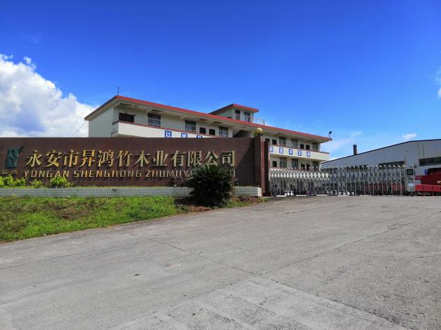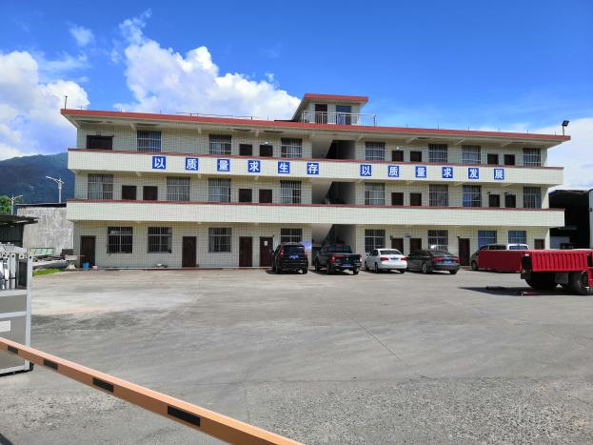

企业简介：

Business Introduction:

福建永安市昇鸿竹木业有限公司坐落于中国笋竹之乡—福建省永安市，是国内资深的竹材综合加工企业之一，也是闻名国内外的老牌竹材胶合板制造商。公司旗下合作生产基地占地近 100000 m²、各类厂房近 50000 m²，年产销竹木复合集装箱地板5 万立方米。

Yongan Shenghong Bamboo & Wood Industry Co., Ltd，is located in the hometown of bamboo shoots, Fujian Province, is one of the senior bamboo comprehensive processing enterprises, is also an old bamboo plywood manufacturer at home and abroad. The cooperative production base of the company covers an area of nearly 100,000 m², factories and nearly 5 0,000 m², annual production and marketing of bamboo and wood composite container floor of 50,000 cubic meters.

公司深耕林业产业多年，深化产业链优势，在福建省先后布局合作多个竹林培育基地及竹材加工基地；与中国海南、泰国、缅甸等多个热带硬木加工基地建立了长久的战略合作伙伴关系。公司加强竹木资源产业布局，为公司原材料质量、产量提供了源头的保障。

The company has been deeply engaged in the forestry industry for many years, deepened the industrial chain advantages, has arranged several bamboo forest cultivation bases and bamboo cultivation bases and bamboo processing bases in Fujian Province; and established long-term strategic partnership with many tropical hardwood processing bases such as Hainan, Thailand, Myanmar, China. The company strengthens the industrial layout of bamboo and wood resources, providing the guarantee for the quality and production of raw materials of the company at the source.

公司不断提升管理体系、深化质量管理，一流的生产设备、严谨的工艺流程、 科学的管理体系、优秀的产业工人，在生产每个环节都精耕细作、力争完美。公司已通过法国 BV 认证。

The company continues to improve the management system, deepen quality management, first-class production equipment, rigorous process process, scientific management system, excellent industrial workers, in every link of production, strive for perfection. The company has been certified by France BV.

公司秉承“优质的质量是我们赖以生存的根本，优质的服务是我们继续发展的前提，客户的满意是我们唯一追求的目标”的经营理念，公司出品的竹木集装箱地板得到国内外众多用户的一致好评，公司与国内外各大集装箱制造商建立了长期良好的合作关系。

Adhering to the business philosophy of "high quality is the fundamental of our survival, quality service is the premise of our continued development, customer satisfaction is the only goal we pursue", the Bomboo&Wood composite Container Flooring has been praised by many users at home and abroad, the company and has established a long-term good cooperation relationship with major container manufacturers at home and abroad.

公司从事板材生产10多年来，凭借先进的生产工艺和丰富的板材从业经验，成为一家集竹木胶合板研发、设计、生产、销售为一体科技创新型企业。公司在竹木加工行业将投入更多的精力，在本行业深耕细作，稳扎稳打，砥砺前行。

The company has been engaged in plate production for more than 10 years, with advanced production technology and rich plate working experience, has become a collection of bamboo plywood research and development, design, production, and sales as an integration of scientific and technological innovative enterprise. The company will invest more energy in the bamboo and wood processing industry, in the industry deep cultivation, steady play, forge ahead.

优质的原材料基地及原材料供应合作伙伴

Quality raw material base and raw material supply partners

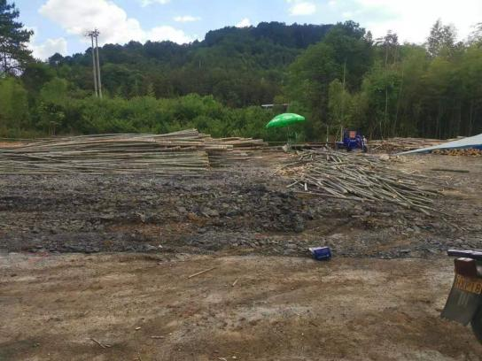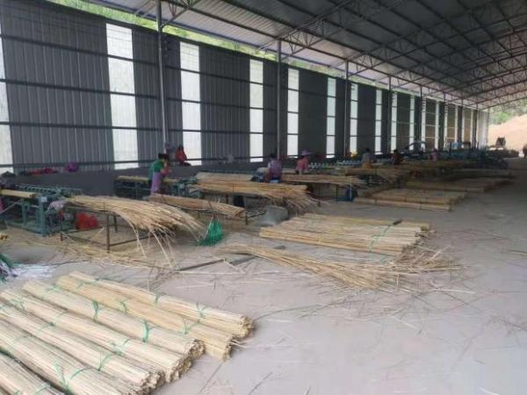

严格的原材料一次烘干和二次烘干

Strict raw materials for primary drying and secondary drying

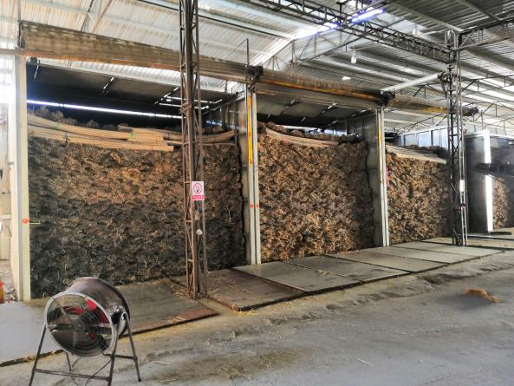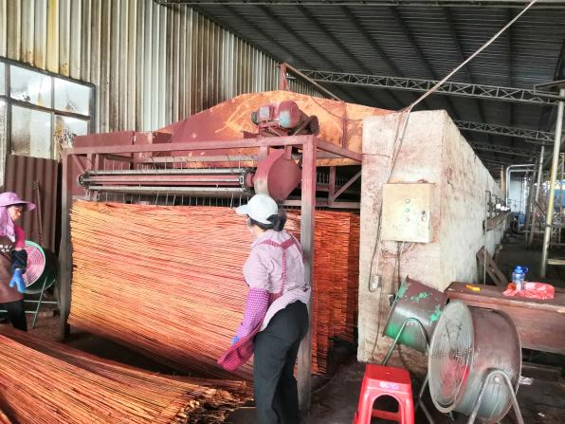

成熟稳定可靠的压机设备及流水线，保证稳定的产品质量和产量供应

Mature stable and reliable compressor equipment and assembly line,Ensure a stable product quality and production supply

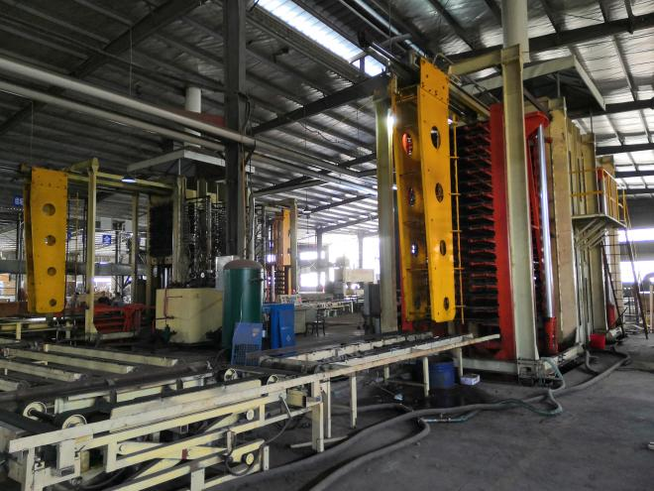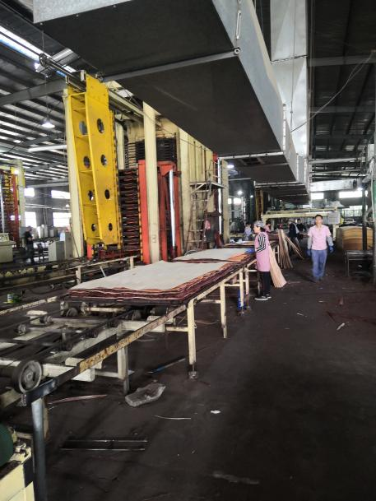

先进的产品检测中心，严格的质量检查体系

The Advanced Product Testing Center,Strict quality inspection system

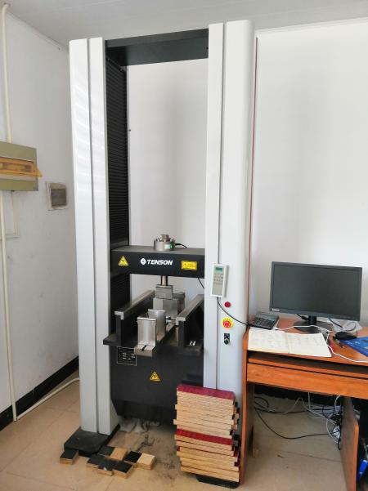 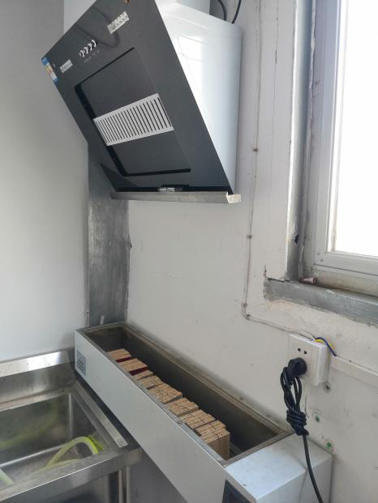

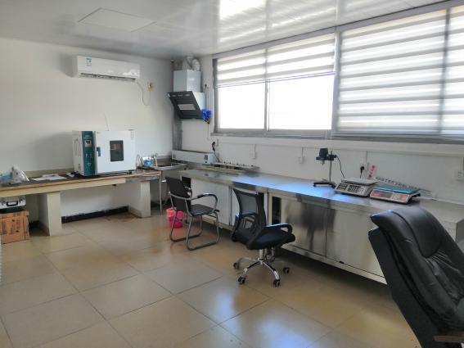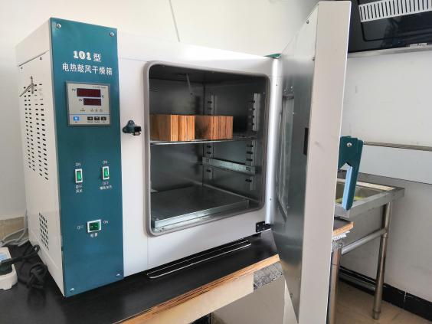

主要产品:

major product :

**竹木复合集装箱地板**

**Bomboo&Wood composite Container Flooring**

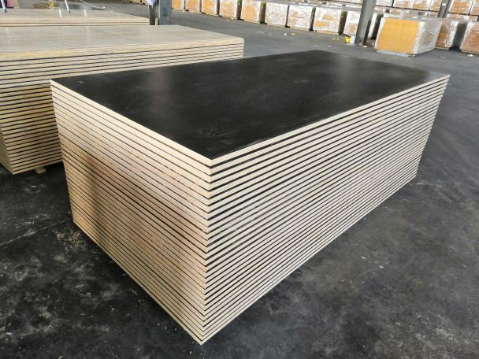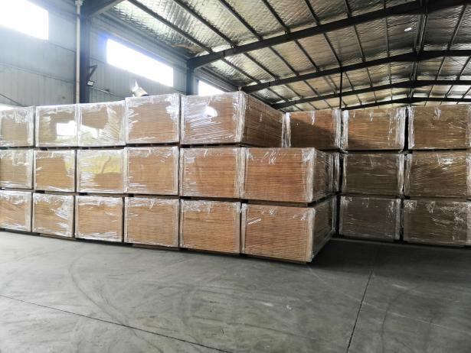

**Contruction-Sustainable Resources 产品介绍—可持续性资源**

In order to comply with the container floor in technology and environmental protection,our company has been tracking the product of the container floor Innovation and development of new materials.

为顺应集装箱地板再生技术和环保方面的提升，我们公司一直跟踪集装箱地板的产品革新和新材料研发使用。

For better service to container industry ,our bamboo wood composite container floor extensive use of local bamboo (Phyllostachys pubescens), which is a kind of fast-growing wood, outstanding enviromental performance , and traditional tropical hardwood floors use slow raw material , such as cloning of wood to about 100 years to become useful , basic is not renewable.

为更好的服务于集装箱行业，我们的竹木复合集装箱地板大量的使用了本地竹子（楠竹） 这种速生材，环保性能突出，而传统的热带硬木地板多使用缓生材，比如克隆木要 100 年左右成才，基本不可再生。

Now this mixed wood floor will be more than the traditional tropical hardwood flooring more forward-looking and enviromental protection. In recent years ,a large number of bamboo flooring use, it also shows that the degree of customer recognition of bamboo flooring is increasing.

现在这种竹木混合地板将比传统的热带硬木地板更具有前瞻性和环保性。近几年竹地板的大量使用，也说明客户对竹地板的认可程度越来越高。

Our company bamboo flooring is made of PSF (Phenolic surface film), bamboo woven-mat, bamboo curtain , wood veneer interlaced assembly. Surface layer of phenolic resin laminated bamboo woven-mat, phenol formaldehyde resin coated wood veneer of two categories; bottom surface layer is bamboo mat, phenolic resin coated and wood veneer. In the thickness and the number of layers on the traditional container wood floor is similar, but also 28mm thick, the total number of layers is not less than 19. The bamboo surface and phenolic coated bamboo flooring can successfully replace PVC container wood floor finishes, the container wood floor surface such as clone wood floor surface as beautiful.

我们公司的竹地板是由 PSF（Phenolic surface film）、竹席、竹帘、木单板交错组合而成。表面层有酚醛树脂膜竹席面、酚醛树脂膜木单板两大类；底面层有竹席的、酚醛覆膜的、木单板的。在厚度和层数上与传统的集装箱木地板相似，也是 28mm 厚，总层数不小于 19 层。竹席面和酚醛覆膜竹地板可以成功替代 PVC 饰面的集装箱木地板，使得集装箱竹木地板表面如克隆木地板表面一样漂亮且更容易进行表面清洁。

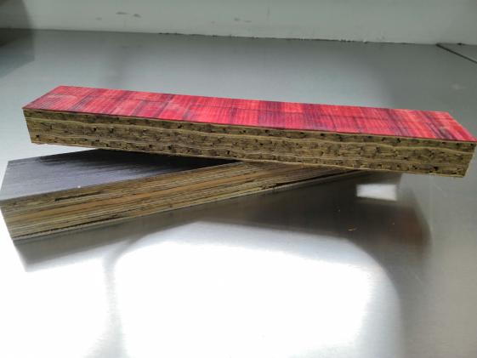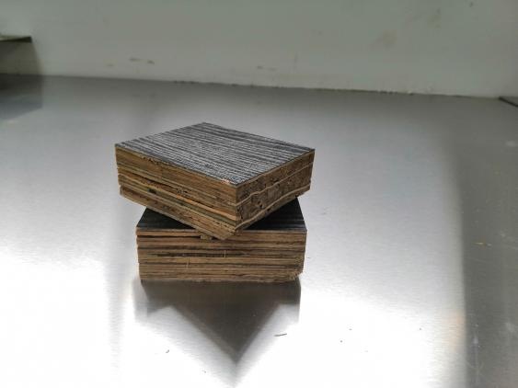

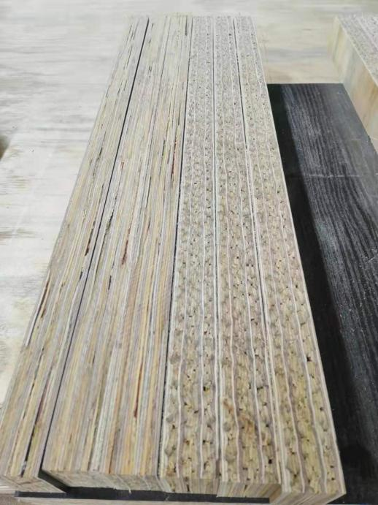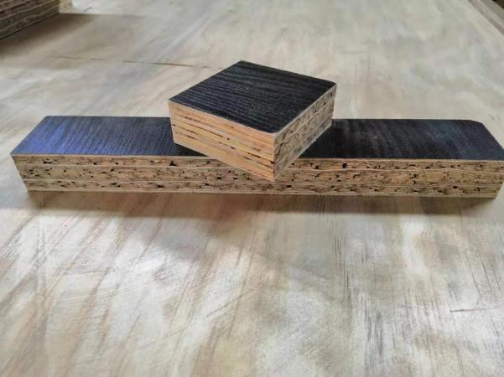

**Charcteristics and advantages of bamboo flooring:**

**竹地板的特点和优点：**

1、durable, PSF film can prevent grease into the wood fiber, easy washing , acid resistance, alkali, resistance.

耐用持久，有 PSF 膜能阻止油渍进入木材纤维，耐磨易洗、防酸、耐碱。

2、high stability, low moisture absorption, small shrinkage, small density difference.

稳定性高，吸湿性低，收缩比例小，密度差异小。

1. for the repair of the floor, a substantial reduction in the rate.

针对地板的修箱率大幅降低。

4、environmental protection, the use of bamboo in more than 65%, rich in resources, is conducive to environmental production.

环保，竹子使用量在 65%以上，资源丰富，属于速生材，利于环保。

**Our company bamboo flooring quality assurance**

**我们公司竹地板质量保证**

1、complete bamboo procurement process monitoring chain from cutting, slitting, weaving to storage have special supervision, age of Que Baozhu, thickness of the water cut rate indicators meet the requirements.

完整的竹帘采购加工监控链条从采伐、开片、编织到入库都有专人监管，确保竹龄、厚度、含水率等各项指标达到要求。

2、the complete quality control system in terms of quality assurance, the company has a strict control, from raw materials to finished products,

for each process, QC carried out the whole process monitoring, to ensure the quality of stability.

完整的质量控制体系，在质量保证方面，公司进行了严格的控制，从原材料到成品， 针对每道工序，QC 进行了全程监控，保证了质量的稳定性。

3、anti-corrosion / pesticides：according to the latest AQIS test procedures, the use of Tailileum 400、Ridaleum FHP-60.

防腐/杀虫剂：根据最新的 AQIS 检验程序，使用 Tailileum 400、Ridaleum FHP-60。

**Product performance is introduced**

**产品性能介绍**

**Bamboo floor classification test 竹地板分类测试**

- *ISO 1496-1 PLUS 33%*

* Car standard test
* 小车标准试验

We of bamboo wood composite container floor performance made a large number of tests. In which the car test ( i.e., each ISO1496-1 plus 33%),is carried out in the ordinary 40’ HQ box, these test results obtained by the French Classification Society (BV) recognition. After the test, there were not any defect of bamboo wood composite container floor and steel structure, successfully passed the test.

我们对竹木复合集装箱地板的性能做了大量的测试试验。其中小车试验（即每ISO1496-1 加 33%），是在普通的 40’HQ 箱上进行的，这些试验的结果得到了法国船级社（BV）的认可。试验后，竹木复合集装箱地板和钢体结构均未出现任何缺损，成功通过了试验检测。

* Laboratory Tests
* 实验室检测

In order to further detect the bearing capacity of the product, we refer to the 19536-2015 GB/T, ASTM (2718-00 D), TB001 IICL (January 02, 2019), has done a

series of laboratory tests, such as bending sthrength , recycling, etc.

为进一步检测产品的可承载力，我们又分别参考 GB/T19536-2015，ASTM (2718-00 D)， IICL TB001 ，先后做了弯曲强度，循环蒸煮等一系列的实验室检测。

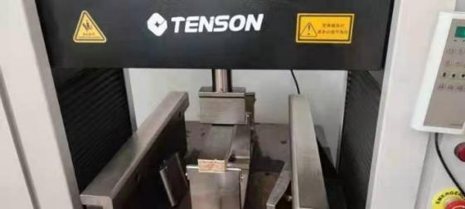 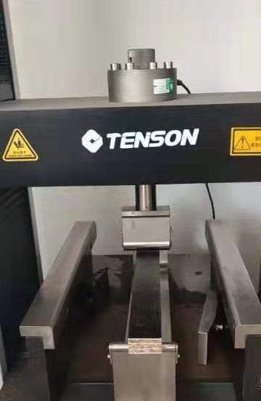

MOR/MOE Test IICL Short Span Test

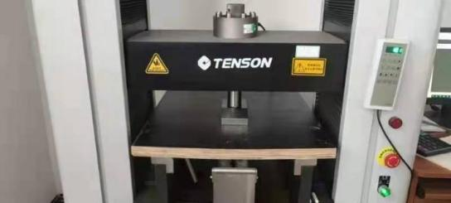 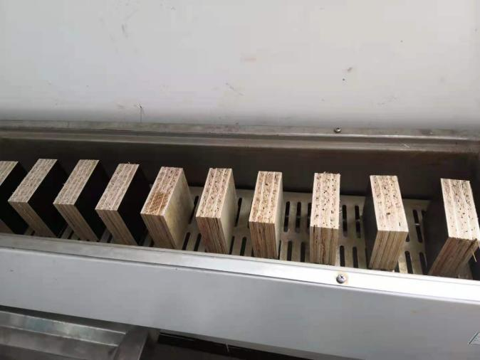

Blocking Test Repeted Billing Test

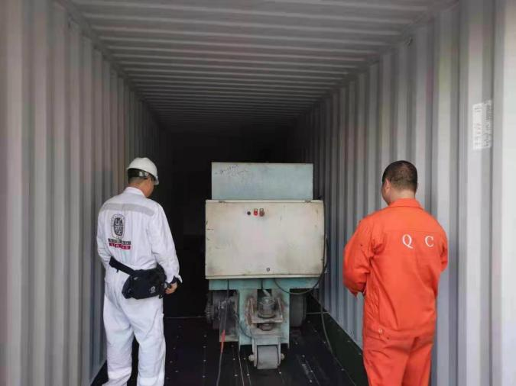 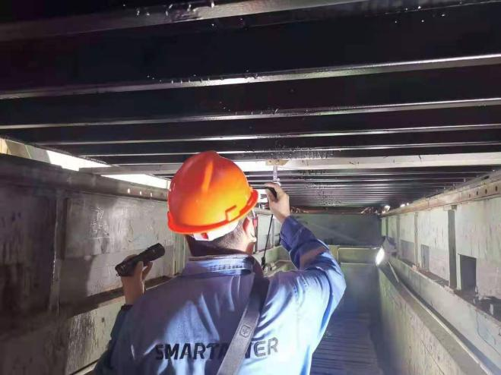

Floor trolley Test（7260kg trolley rolling）

**永安市昇鸿竹木业有限公司**

**Yongan Shenghong Bamboo & Wood Industry Co., Ltd**

**地址：福建省永安市贡川镇水东工业园区9号**

**Address: No. 9 Shuidong Industrial Park, Gongchuan Town, Yongan City, Fujian**

**联系电话:0598-3510505**

**Contact number: +86 598 351 0505**

**移动电话:18960598128**

**Mobile telephone:+86 18960598128**

**企业邮箱：shenghong@yongan-shenghong.com**

**Enterprise mailbox：shenghong@yongan-shenghong.com**